Understanding development tools and environments

The development environment is a collection of hardware & software tools, which are used by software developers to build software applications, authors of web pages and web sites, also use these tools.

The environment is a workspace [app] or [program], which gived the user a set of processing and programming tools, where they can source code for web pages.

Whereas **Microsoft Word** is a *processor for building/writing documents [letters, statements, reports etc]*,a software developer application is a processor for building/writing code for web pages.

There are three types of development environments;[1]

* Language environments- *supports program language with related tools.*
* Structure-oriented environments- *enables users to manipulate the layouts.*
* Toolkit environments- *collection of tools [language support, configuration,version control].*

## Development Server

Used to write & test code, application performance before the next stage.

* Language [HTML.CSS, English]
* Content and page layout
* Formatting text.

There are many companies offering development applications known as IDE [2]such as;

* Visual studio *“my preferred choice after researching other sites, mainly because its a free source site, but it also includes ample resources {corrections [3], easy access to HTML and CSS plus a multitude of other applications for repository’s [4]}”*
* Netbeans
* CODA 2
* Komodo Edit

## Staging server

Similar to the development server, this stage enables the developer to run tests, to ensure reliability, and ensure the code works correctly before the user adds it to the production server.[5]

## Production Server

Usually called a host server, posts your work onto the internet, using a domain and IP address, offers different host plans [duration, web page sizes, and posts].

# Project Methodologies

Project Methodologies are management frameworks that enable the user to manage your project, in an effective visual manner. The framework highlights the range and progress of a project through different levels of completion, showing the user the next element of a project, stating that level's task.[6]

There are many different frameworks the user can consider;

### Waterfall- best used for

* + Software development
  + Supply chains
  + Manufacturing Projects

## 

### Agile - allows for parallel development and testing

### **Phase 1: Requirements**

### **Phase 2: Design**

### **Phase 3. Development and Coding**

### **Phase 4: Integration and Testing**

### **Phase 5. Implementation and Deployment**

### **Phase 6: Review**

## 

### Scrum[7]- divided into iterations or sprints[8]

### Carried out by 7-9 people

* + Scrum master
  + Product owner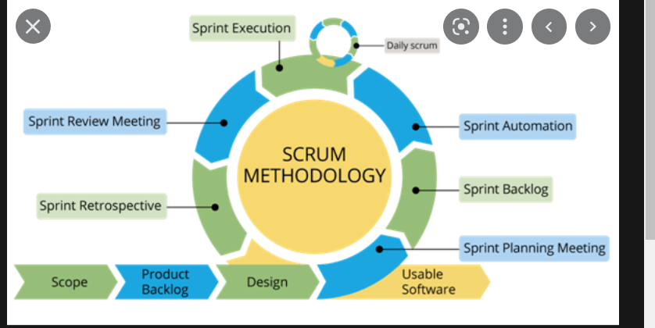

### Extreme Programming[9]- allows small sized teams to produce quality software

* + Values
  + Principles
  + Practices
  + 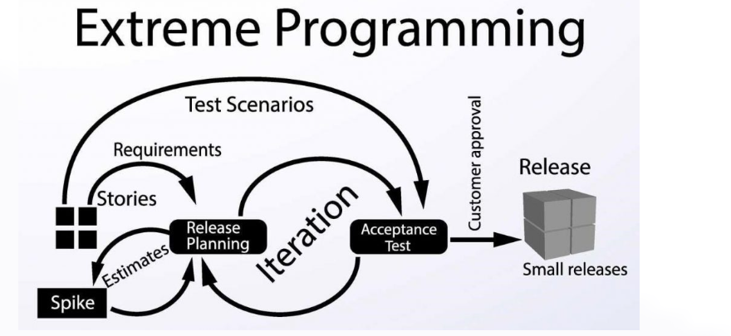

1. https://www.techtarget.com/searchsoftwarequality/definition/development-environment
2. Integrated Development Environment
3. Similar to editor in Word
4. Projects
5. Markup Validation
6. https://www.teamwork.com/project-management-guide/project-management-methodologies/
7. https://www.atatus.com/glossary/agile-methodology/#what-is-agile-methodology
8. Set of features of the project, that are allocated to a person and committed to a timeline.
9. Good practices taken to an extreme.